Extended Data File 6: Visualisation Examples Catalogue
Decision-support toolkit for visualising accelerometer-derived movement behaviour data
This document contains 32 generated visualisation examples: 9 published-study application examples and 23 simulated data examples.
Published-study application examples were generated from the reproduced NHANES 2011-2014 published-study application outputs. Simulated data examples were generated from small mock datasets to illustrate recommendation-specific visual structures and should not be interpreted as evidence that the designs have been empirically tested.

Published-study application examples
Figures generated from the reproduced data reconstructed for the published-study applicationset and associated summary outputs.

Published-study application example 1. Weekday and weekend-day physical activity by sample
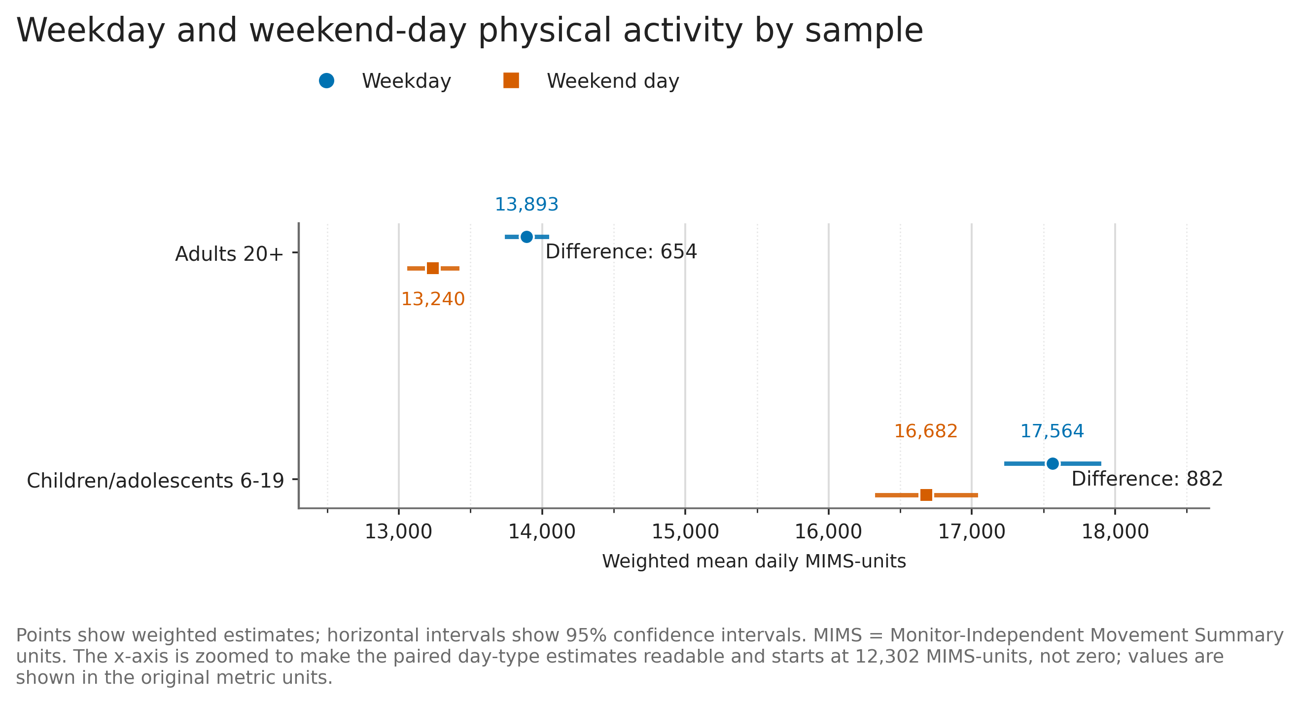
Weighted mean daily MIMS-units on weekdays and weekend days for adults and children/adolescents. Points show estimates, horizontal intervals show 95% confidence intervals, and text labels report the descriptive weekday-minus-weekend difference. No statistical significance marker is shown.
Source: Worked application to a published study, reproduced NHANES 2011-2014 data.

Published-study application example 2. Weekday-weekend physical activity difference by subgroup: Adults 20+
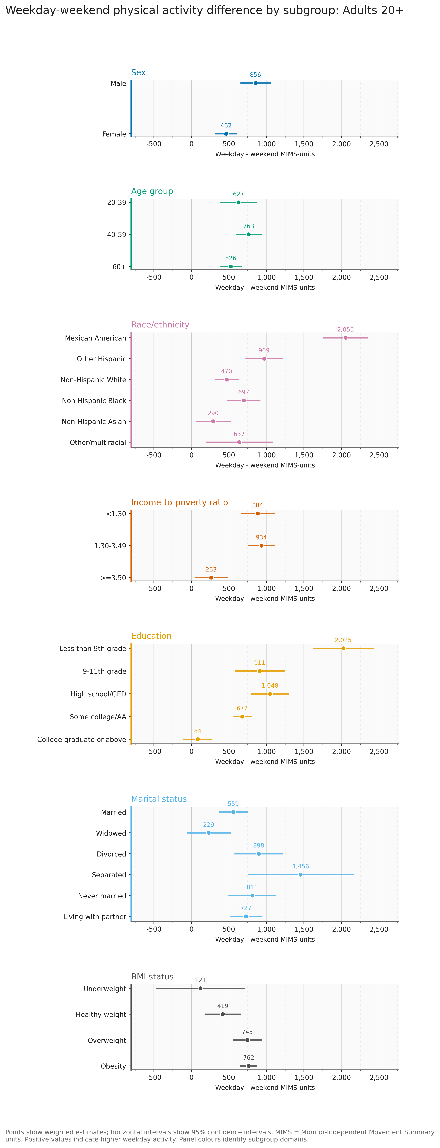
Weighted weekday-minus-weekend MIMS-unit differences by subgroup for Adults 20+. Positive values indicate higher weekday physical activity. Points show estimates and horizontal intervals show 95% confidence intervals. Panel colours identify subgroup domains.
Source: Worked application to a published study, reproduced NHANES 2011-2014 data.

Published-study application example 3. Weekday-weekend physical activity difference by subgroup: Children/adolescents 6-19
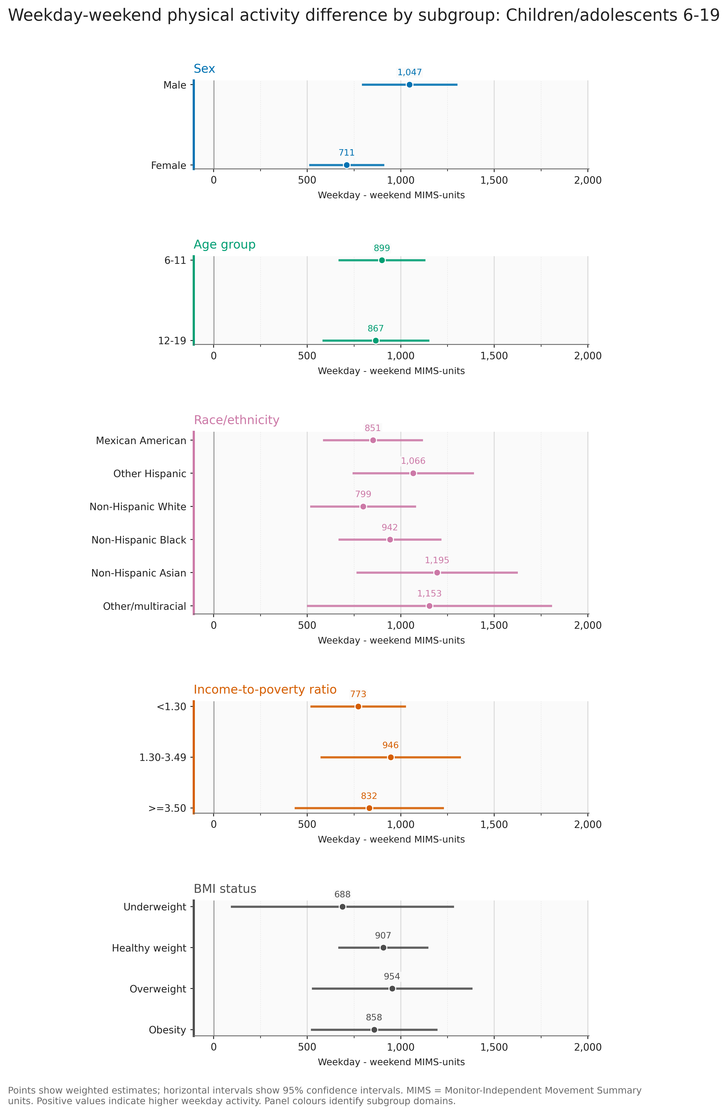
Weighted weekday-minus-weekend MIMS-unit differences by subgroup for Children/adolescents 6-19. Positive values indicate higher weekday physical activity. Points show estimates and horizontal intervals show 95% confidence intervals. Panel colours identify subgroup domains.
Source: Worked application to a published study, reproduced NHANES 2011-2014 data.

Published-study application example 4. Weekday and weekend-day physical activity by subgroup: Adults 20+
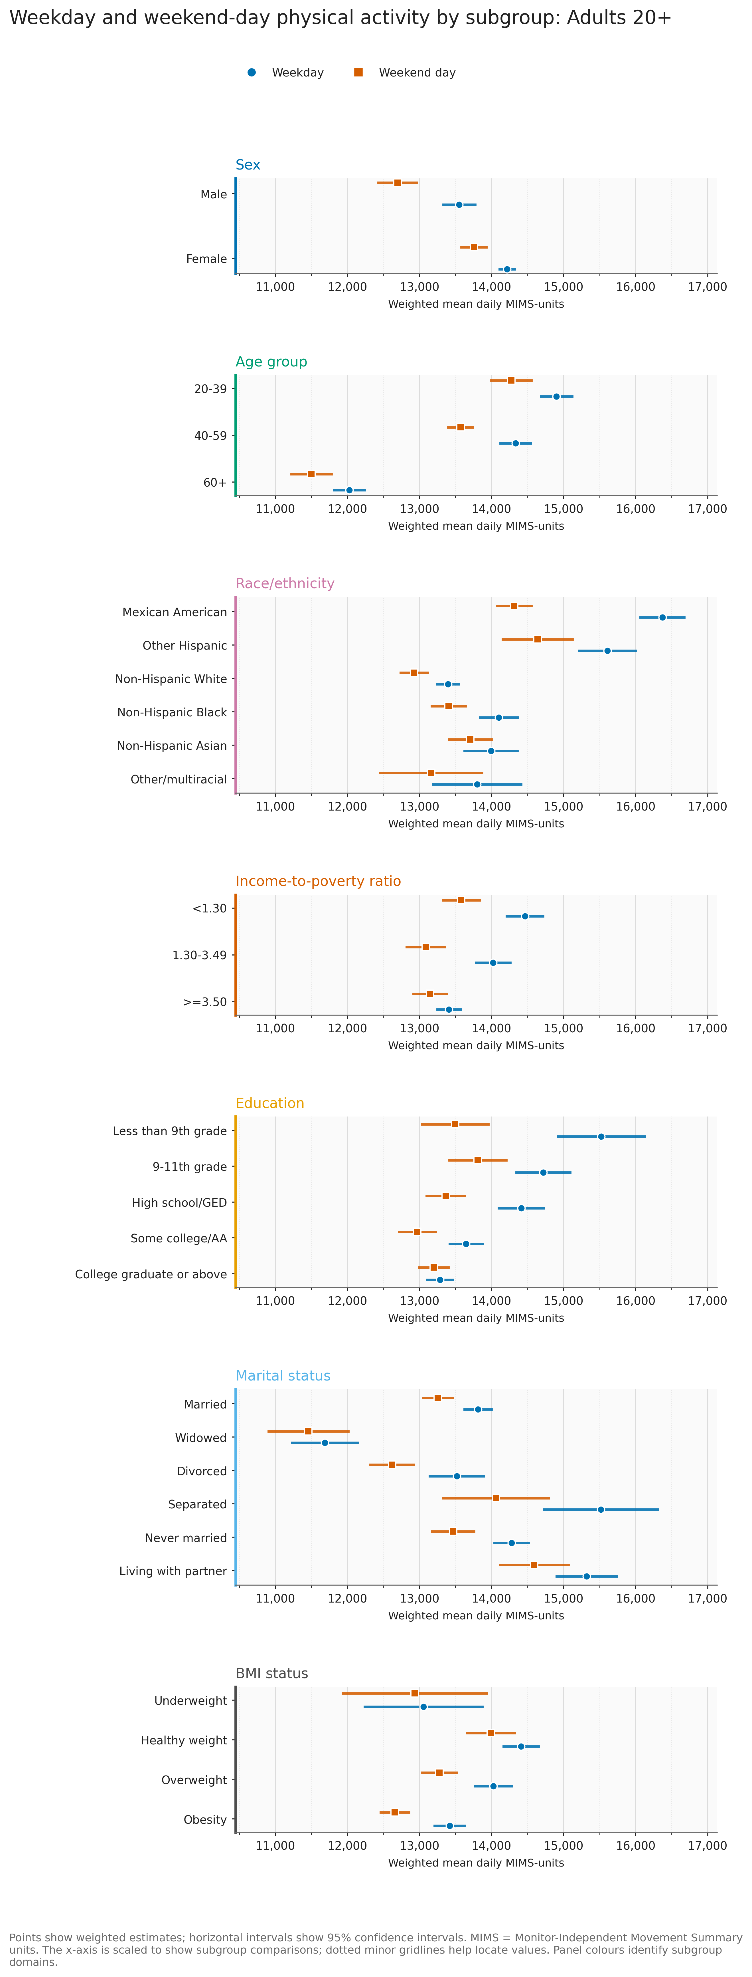
Weighted mean daily MIMS-units on weekdays and weekend days by subgroup for Adults 20+. Points show estimates and horizontal intervals show 95% confidence intervals. Panel colours identify subgroup domains.
Source: Worked application to a published study, reproduced NHANES 2011-2014 data.

Published-study application example 5. Weekday and weekend-day physical activity by subgroup: Children/adolescents 6-19
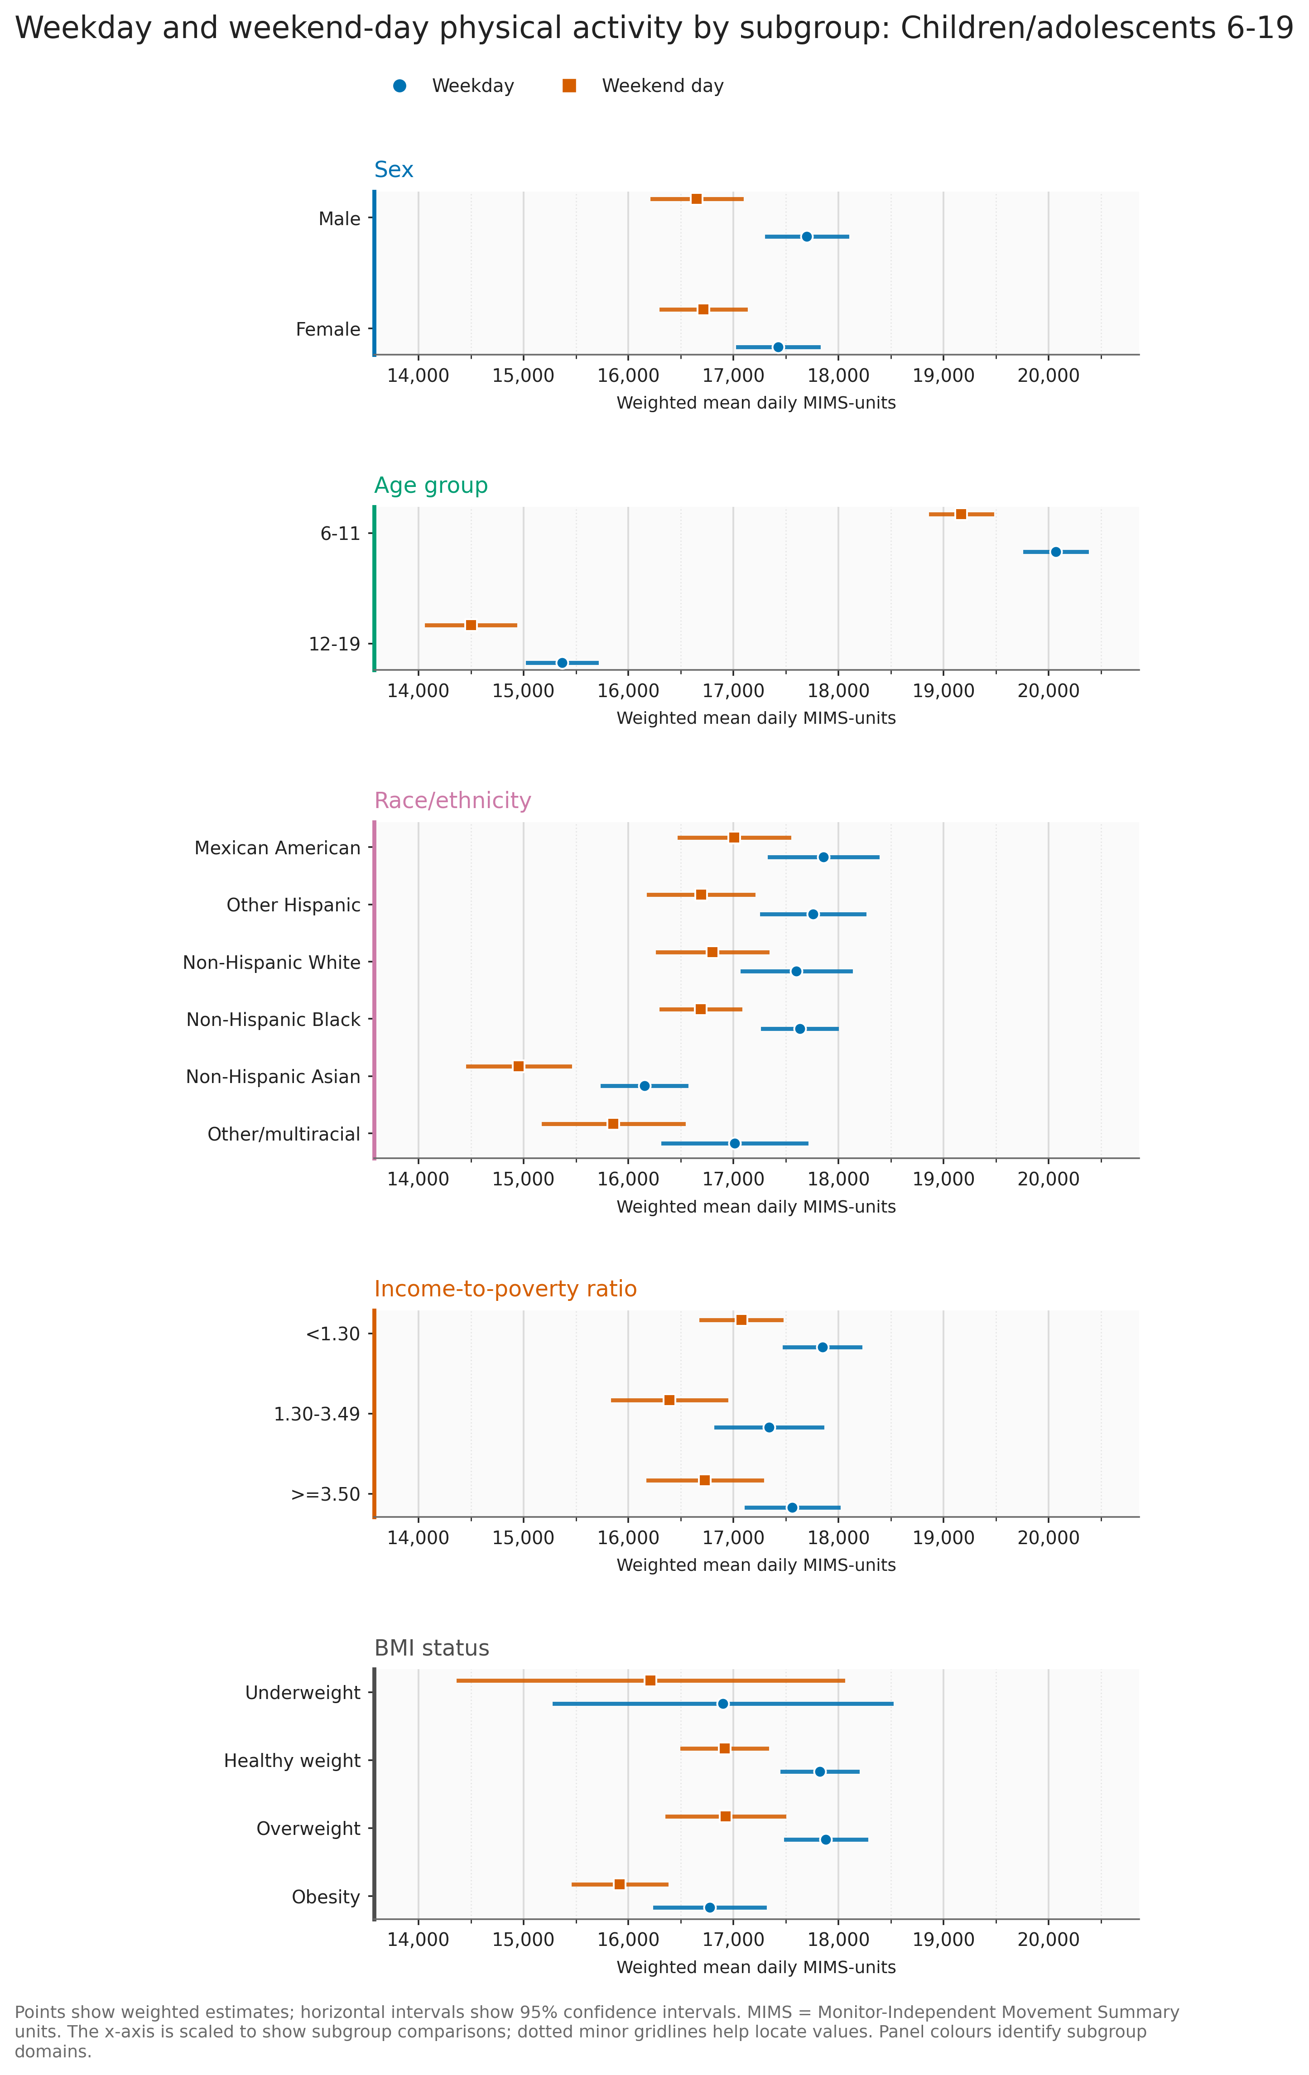
Weighted mean daily MIMS-units on weekdays and weekend days by subgroup for Children/adolescents 6-19. Points show estimates and horizontal intervals show 95% confidence intervals. Panel colours identify subgroup domains.
Source: Worked application to a published study, reproduced NHANES 2011-2014 data.

Published-study application example 6. Distribution of individual weekday-weekend differences
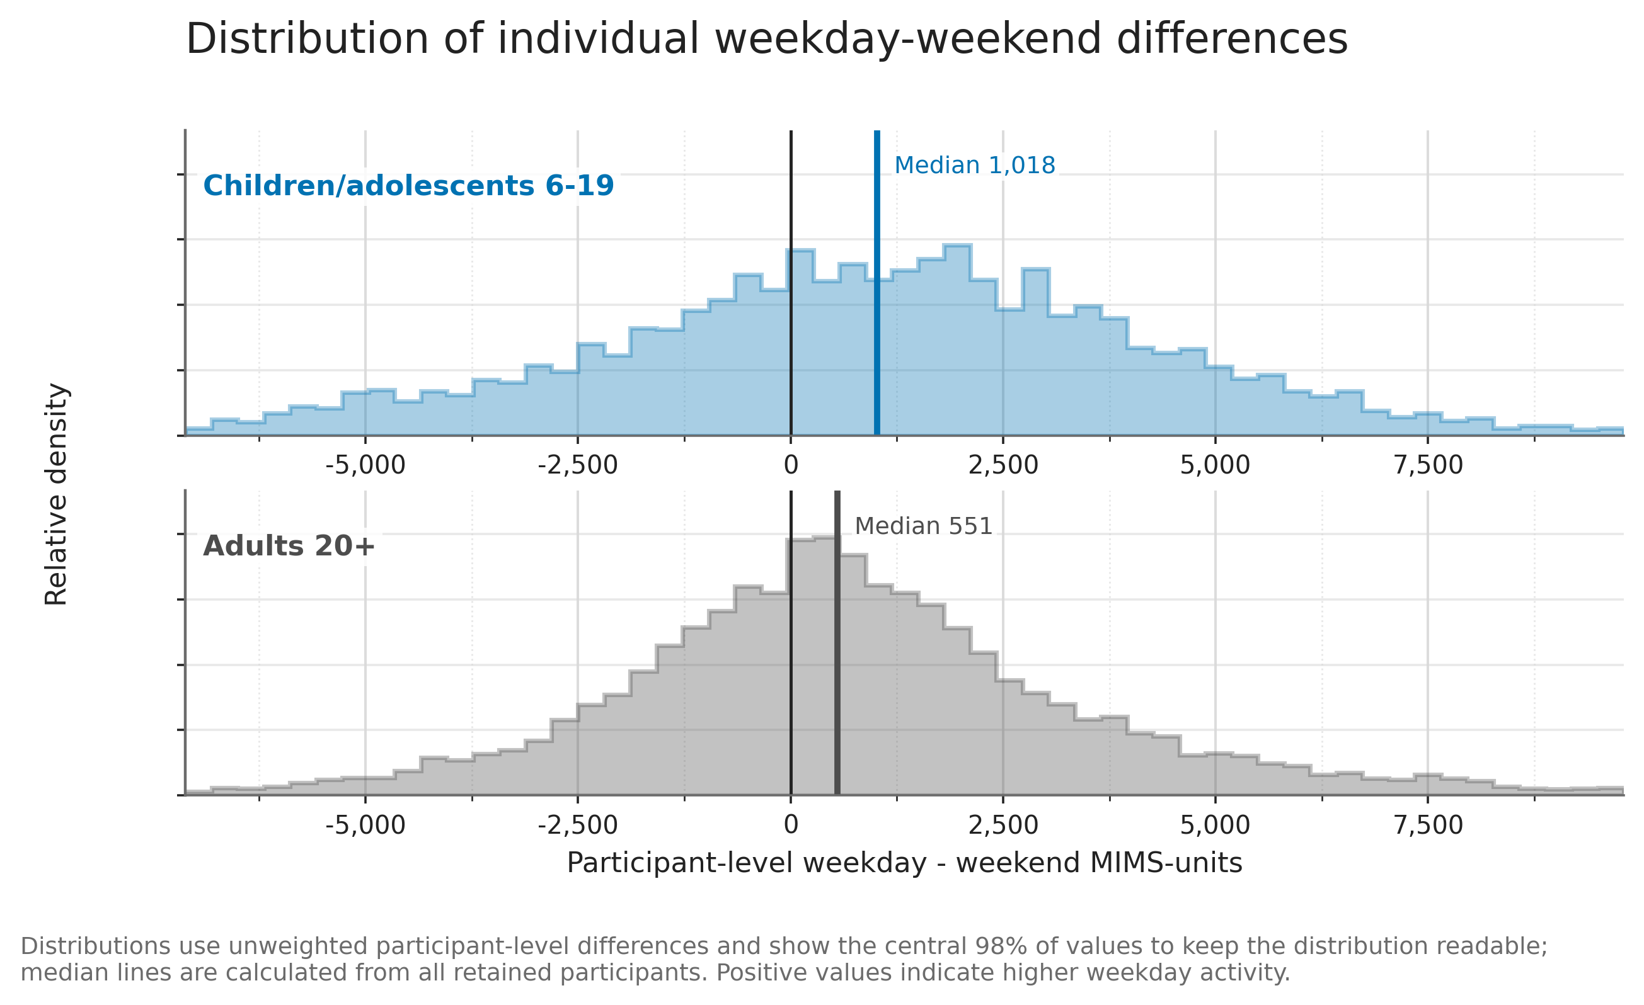
Distribution of participant-level weekday-minus-weekend MIMS-unit differences for adults and children/adolescents. Positive values indicate higher weekday physical activity. The axis shows the central 98% of values for readability.
Source: Worked application to a published study, reproduced NHANES 2011-2014 data.

Published-study application example 7. Participant-level relationship between weekday and weekend-day activity
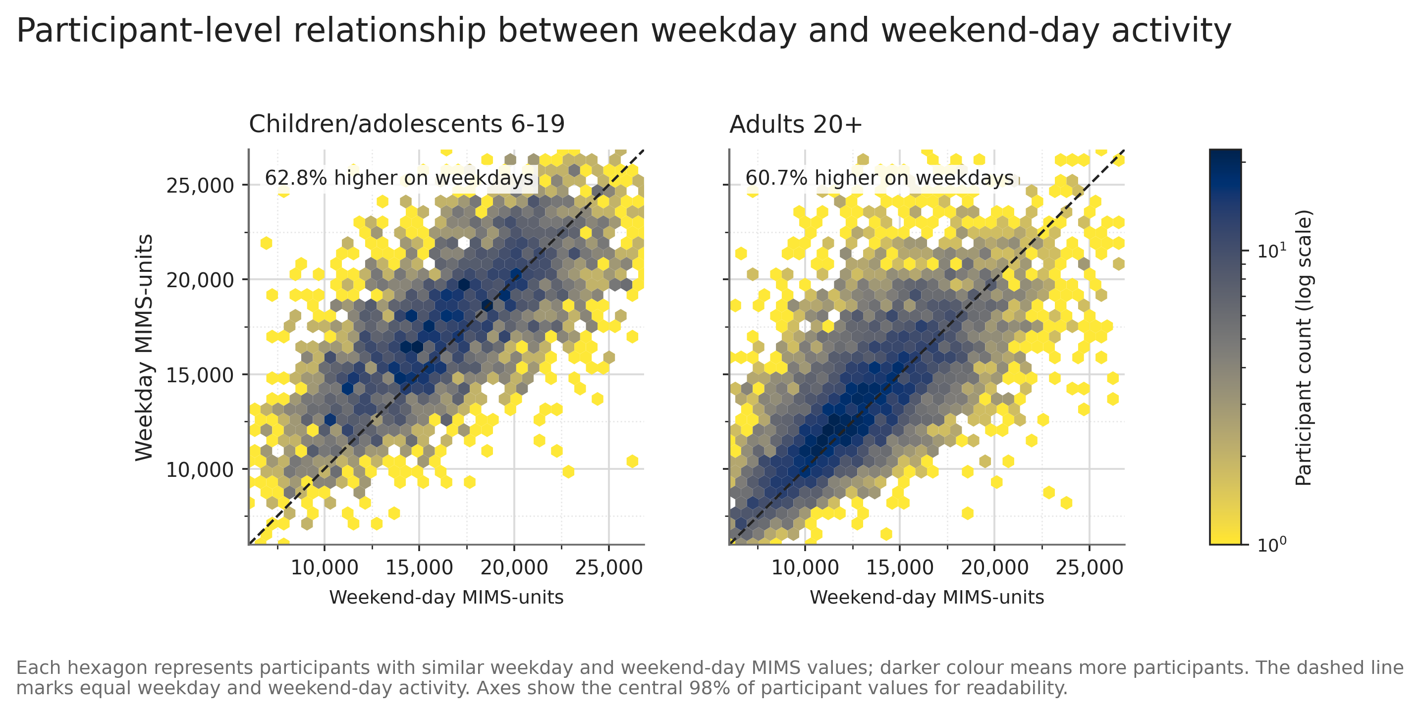
Hexbin plots showing the participant-level relationship between mean weekend-day and weekday MIMS-units. The dashed line represents equal weekday and weekend-day activity; points above the line indicate higher weekday activity.
Source: Worked application to a published study, reproduced NHANES 2011-2014 data.

Published-study application example 8. Percentage weekday-weekend difference by sample
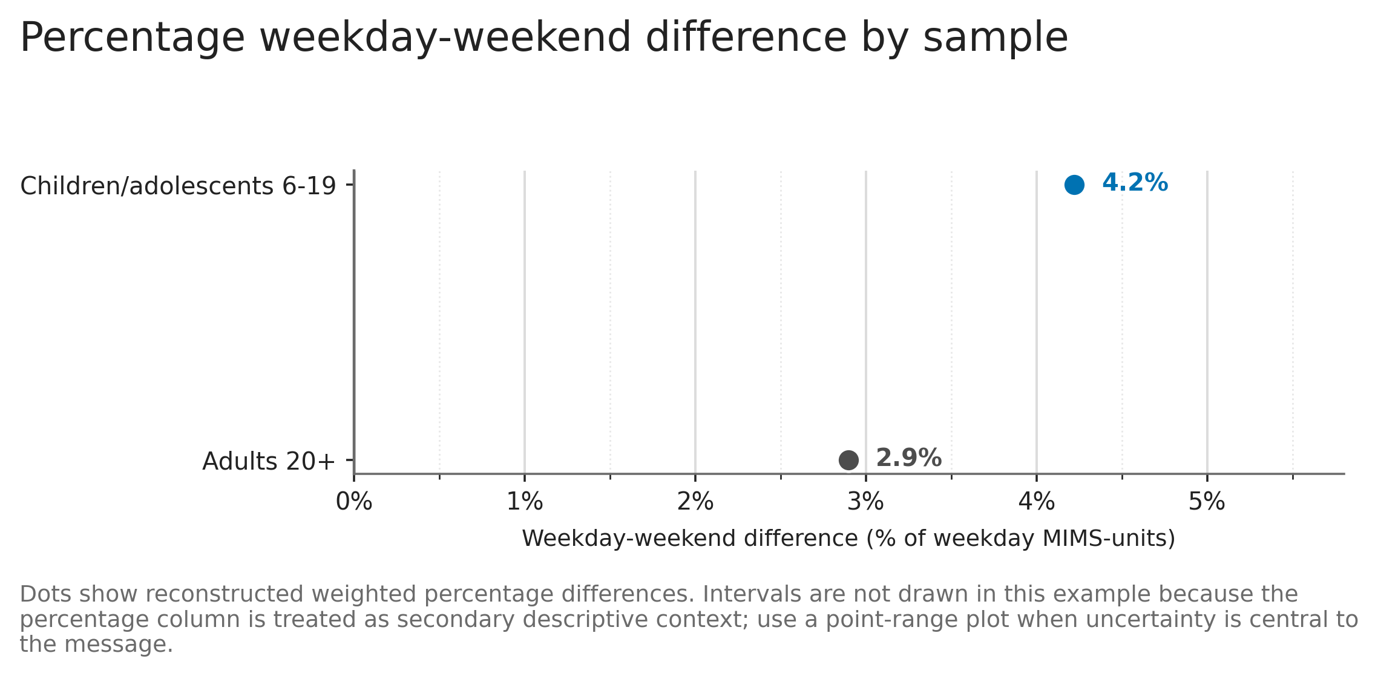
Reconstructed weekday-weekend percentage differences relative to weekday MIMS-units for adults and children/adolescents. Dots show weighted summary percentages without intervals.
Source: Worked application to a published study, reproduced NHANES 2011-2014 data.

Published-study application example 9. Conditional bar-chart example: percentage difference by sample
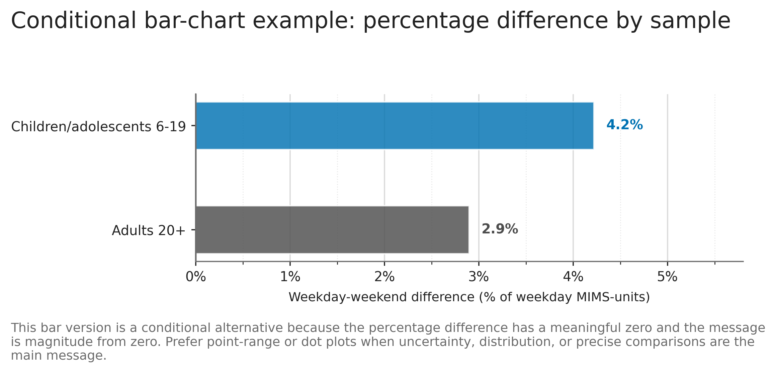
Conditional bar-chart version of the reconstructed weekday-weekend percentage differences relative to weekday MIMS-units. Bar length represents percentage difference from zero.
Source: Worked application to a published study, reproduced NHANES 2011-2014 data.

Simulated data examples
Figures generated from small simulated mock datasets to illustrate recommendation-specific visual structures.

Simulated example 1. Behaviour timeline (tile plot)
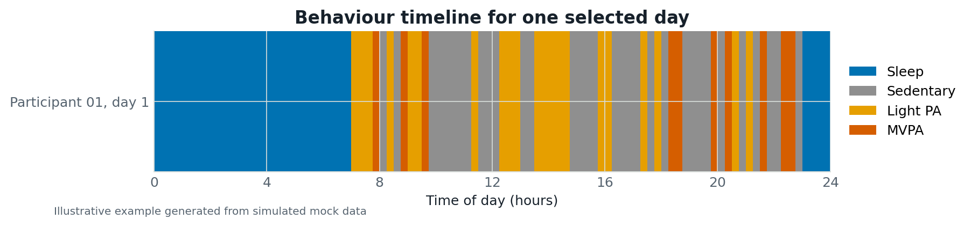
Simulated data example illustrating the visual structure for the recommendation: Behaviour timeline (tile plot).
Source: Simulated mock data.

Simulated example 2. Behaviour-by-time heatmap
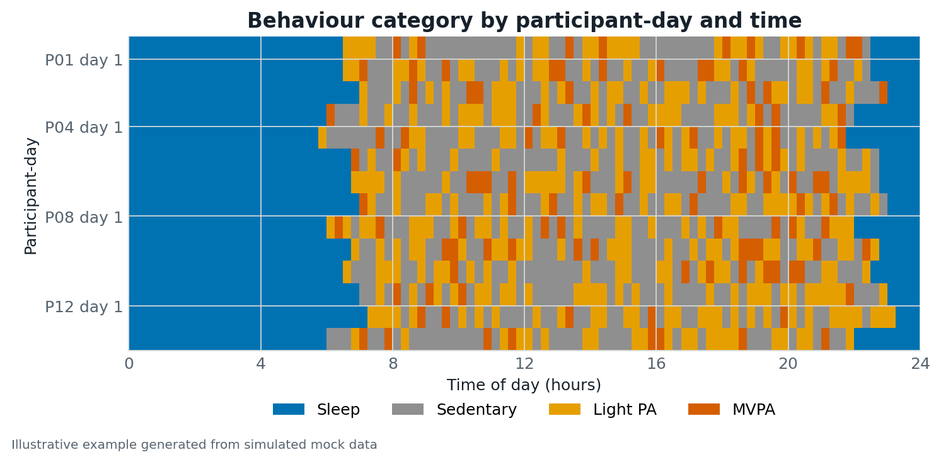
Simulated data example illustrating the visual structure for the recommendation: Behaviour-by-time heatmap.
Source: Simulated mock data.

Simulated example 3. Proportion-over-time profile
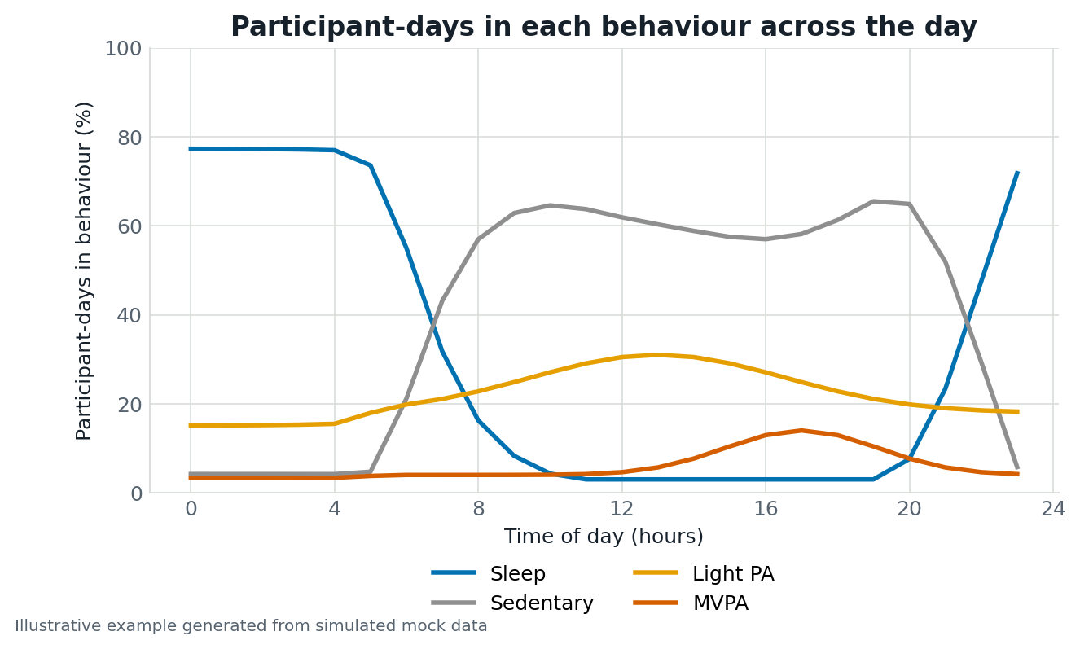
Simulated data example illustrating the visual structure for the recommendation: Proportion-over-time profile.
Source: Simulated mock data.

Simulated example 4. Stacked area profile
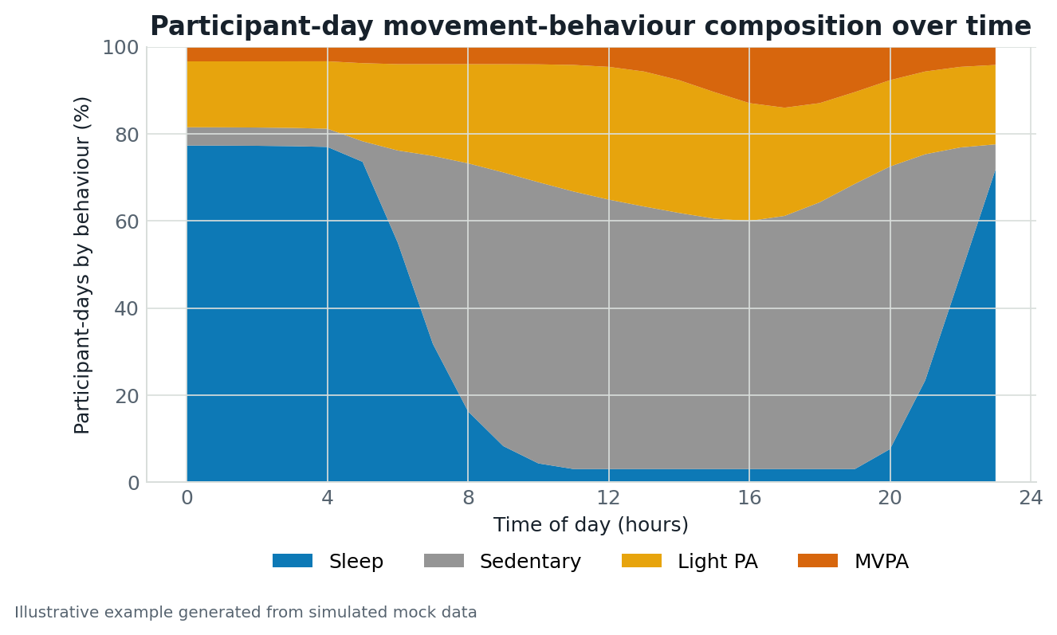
Simulated data example illustrating the visual structure for the recommendation: Stacked area profile.
Source: Simulated mock data.

Simulated example 5. Time-series line plot
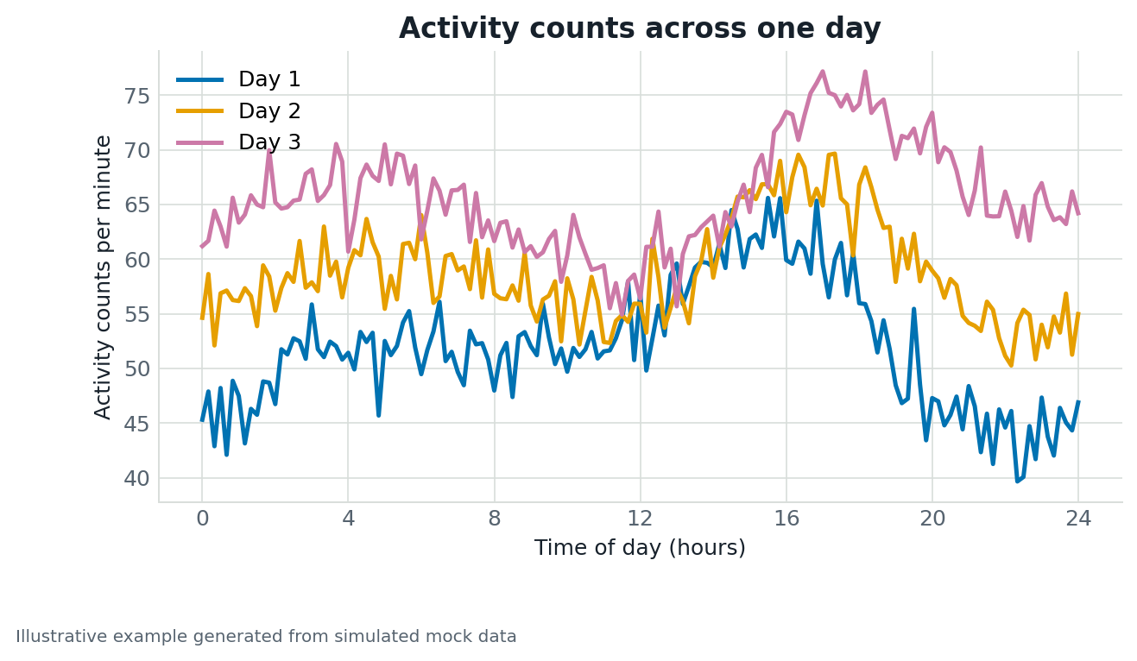
Simulated data example illustrating the visual structure for the recommendation: Time-series line plot.
Source: Simulated mock data.

Simulated example 6. Observation-by-time heatmap
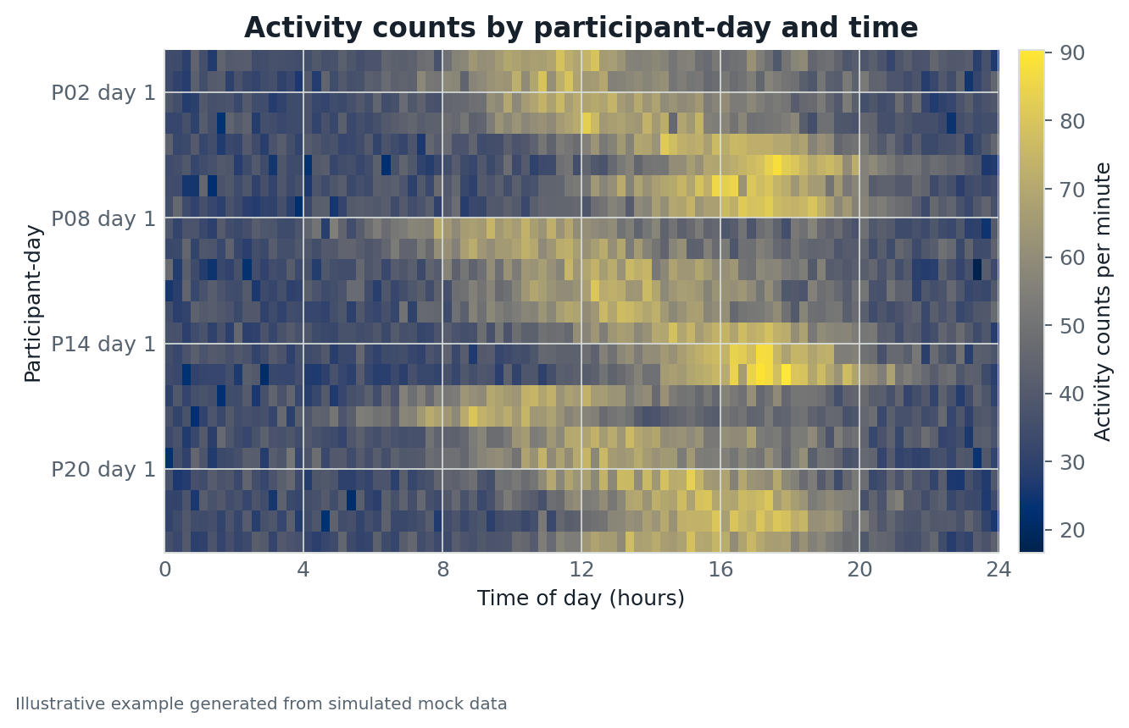
Simulated data example illustrating the visual structure for the recommendation: Observation-by-time heatmap.
Source: Simulated mock data.

Simulated example 7. Small-multiple time-series plots
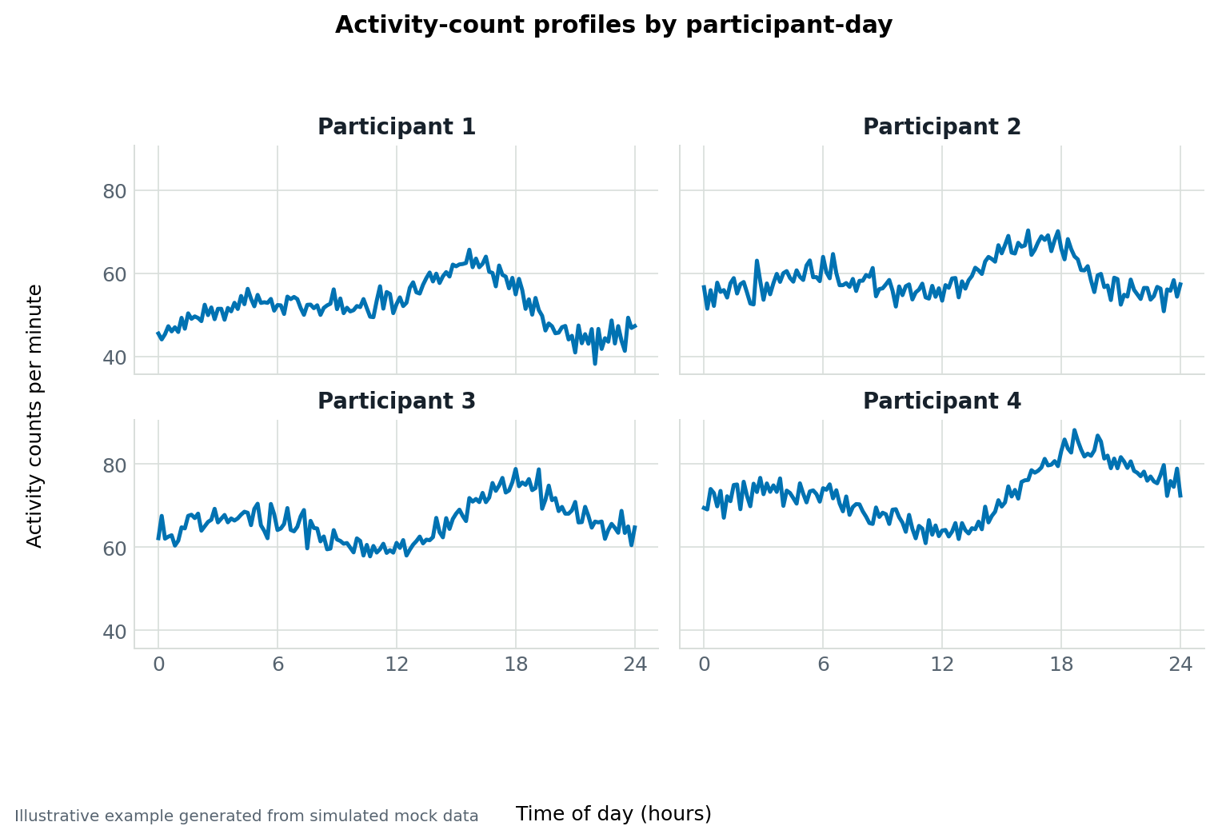
Simulated data example illustrating the visual structure for the recommendation: Small-multiple time-series plots.
Source: Simulated mock data.

Simulated example 8. Summary time profile with interval ribbon
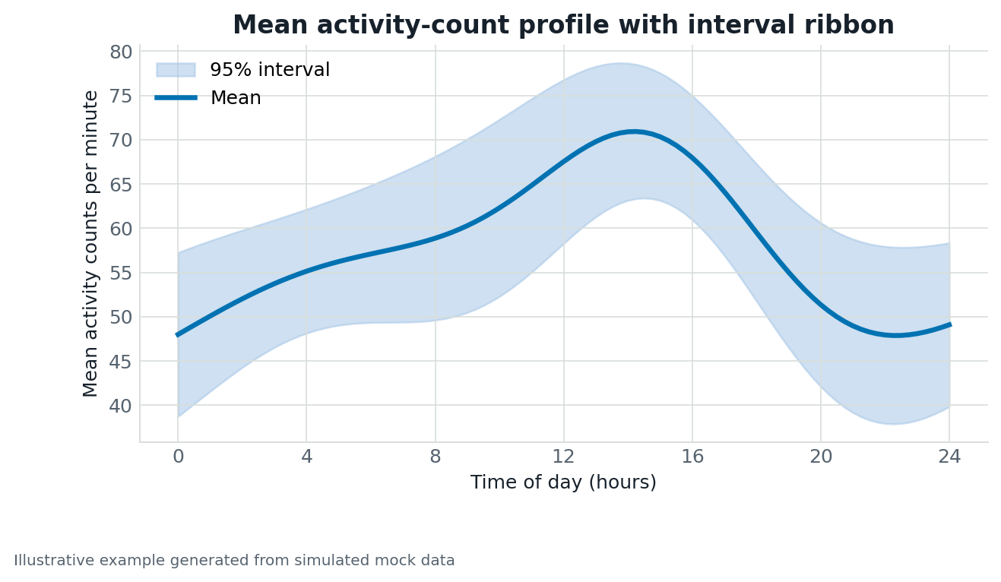
Simulated data example illustrating the visual structure for the recommendation: Summary time profile with interval ribbon.
Source: Simulated mock data.

Simulated example 9. Summary time profile
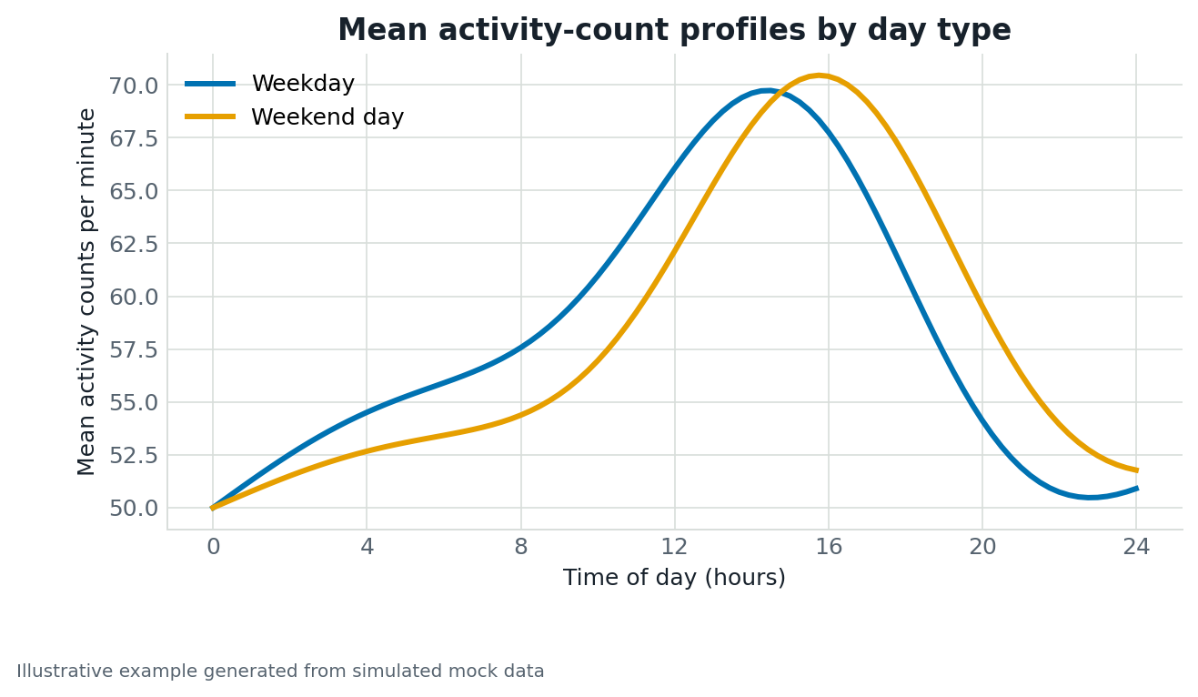
Simulated data example illustrating the visual structure for the recommendation: Summary time profile.
Source: Simulated mock data.

Simulated example 10. Empirical cumulative distribution (ECDF)
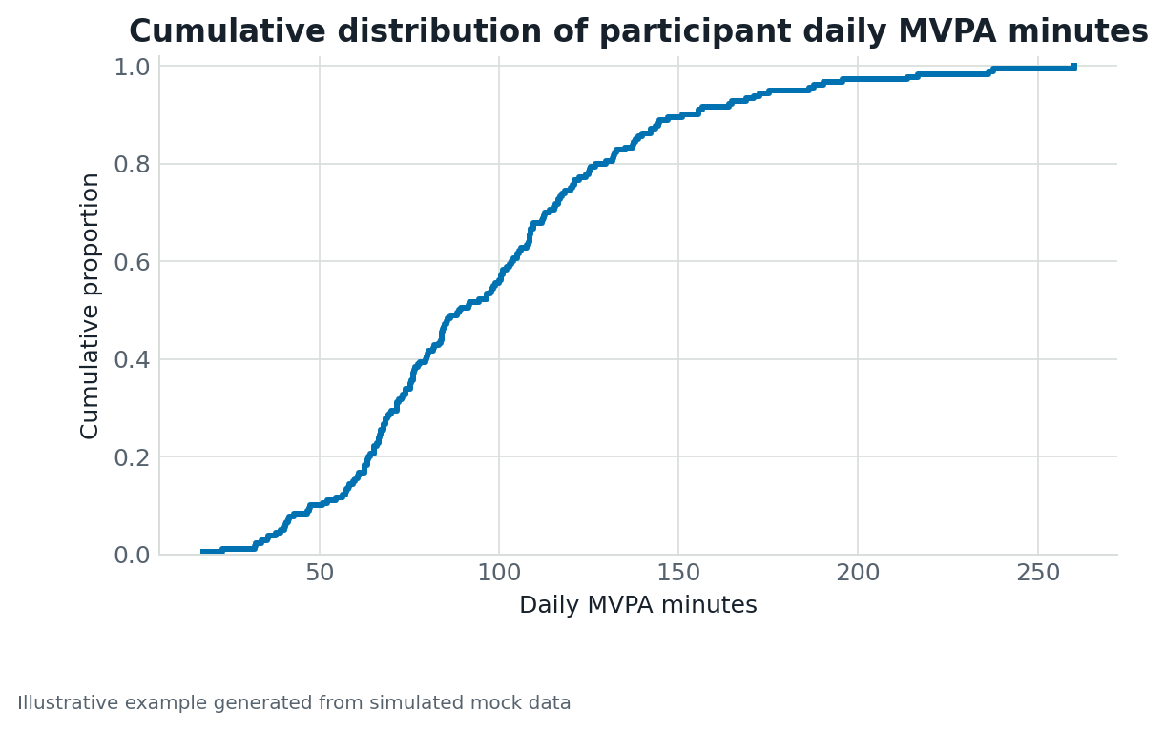
Simulated data example illustrating the visual structure for the recommendation: Empirical cumulative distribution (ECDF).
Source: Simulated mock data.

Simulated example 11. Box or violin plot with raw points
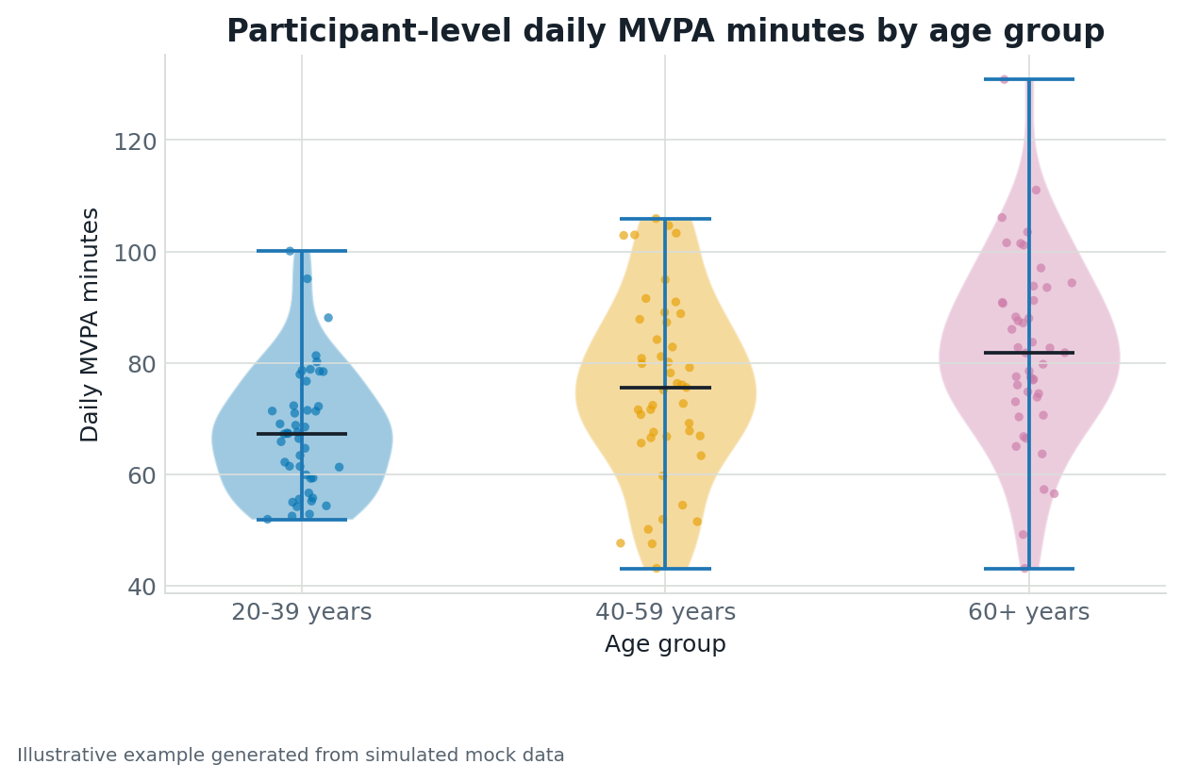
Simulated data example illustrating the visual structure for the recommendation: Box or violin plot with raw points.
Source: Simulated mock data.

Simulated example 12. Faceted density or ECDF plot
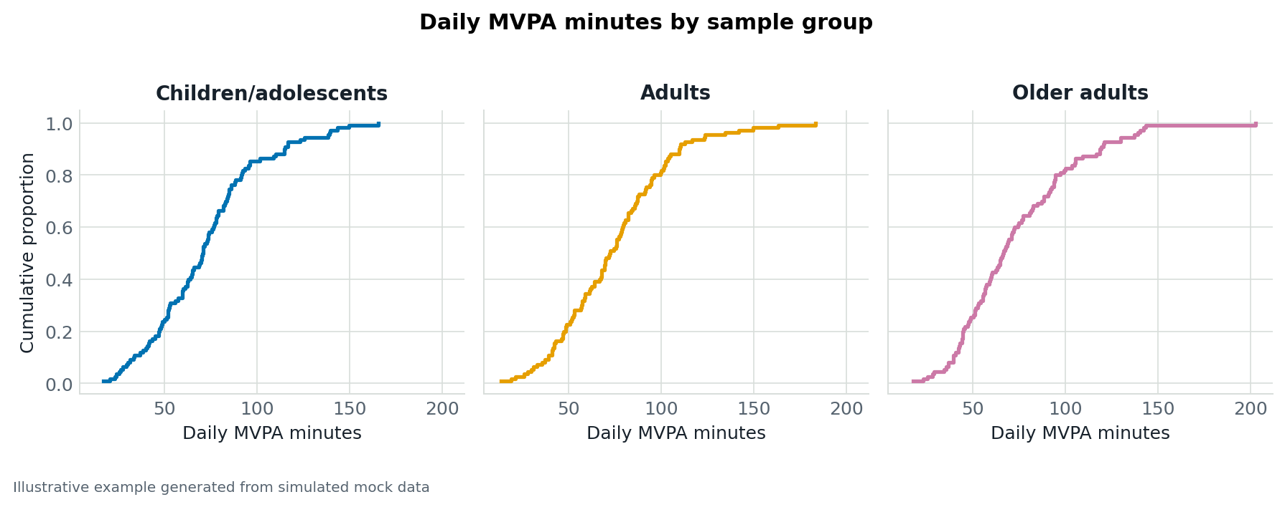
Simulated data example illustrating the visual structure for the recommendation: Faceted density or ECDF plot.
Source: Simulated mock data.

Simulated example 13. Repeated-measures line plot
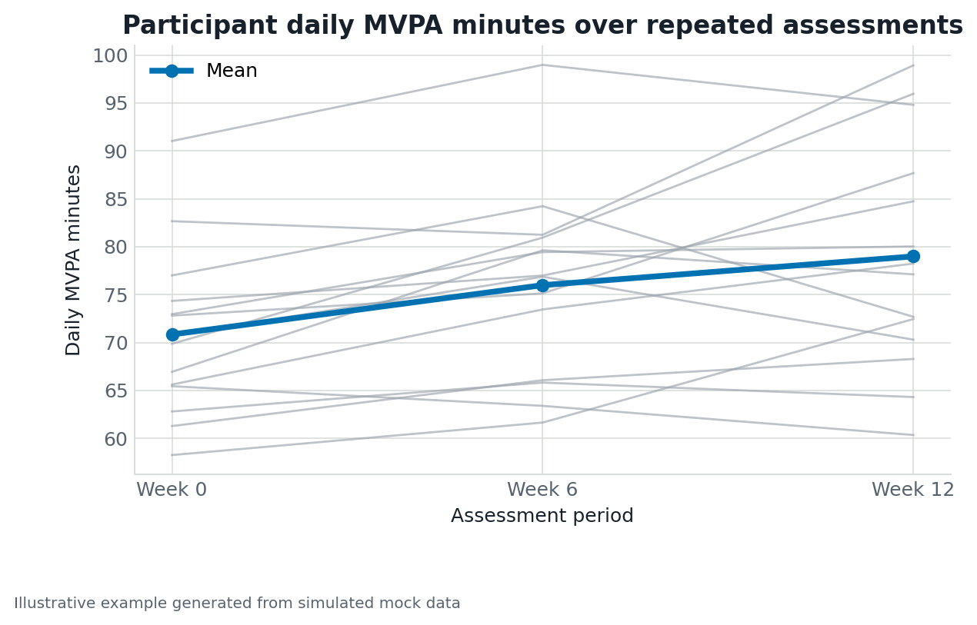
Simulated data example illustrating the visual structure for the recommendation: Repeated-measures line plot.
Source: Simulated mock data.

Simulated example 14. Dot plot with summary and interval
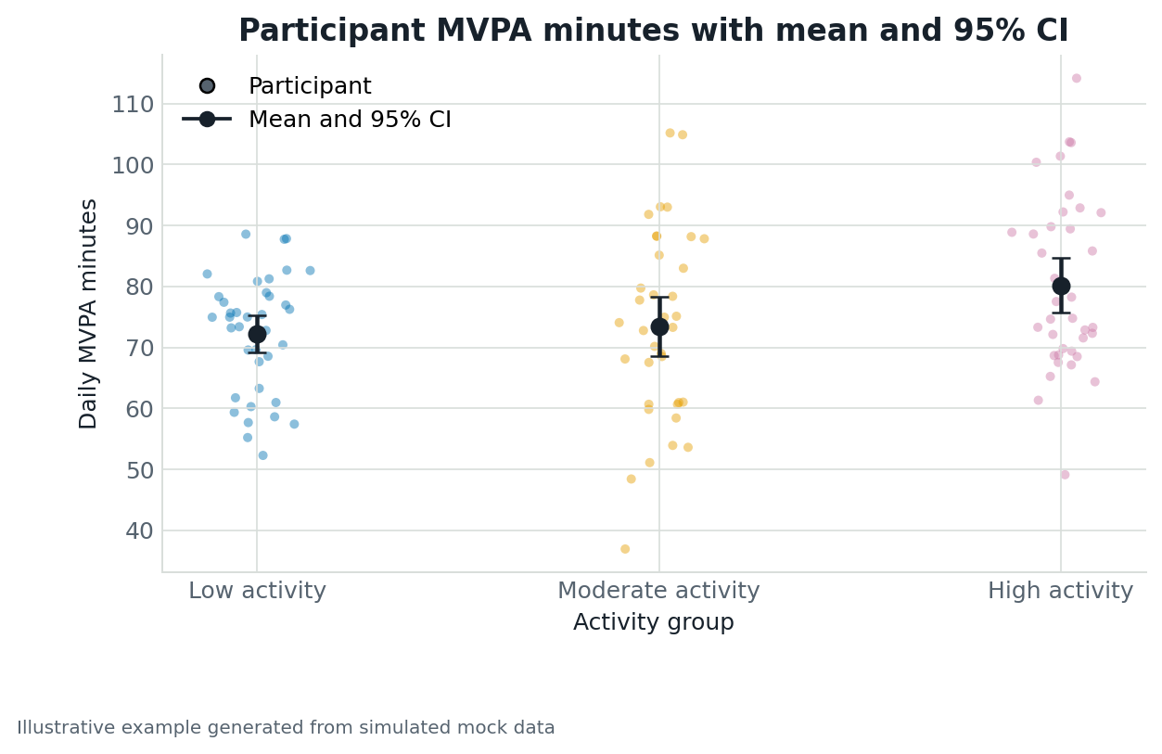
Simulated data example illustrating the visual structure for the recommendation: Dot plot with summary and interval.
Source: Simulated mock data.

Simulated example 15. Dot plot of observed values
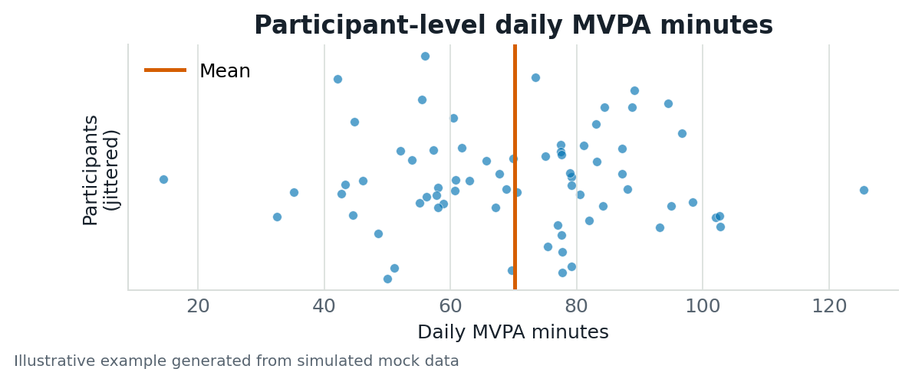
Simulated data example illustrating the visual structure for the recommendation: Dot plot of observed values.
Source: Simulated mock data.

Simulated example 16. Pie or doughnut chart
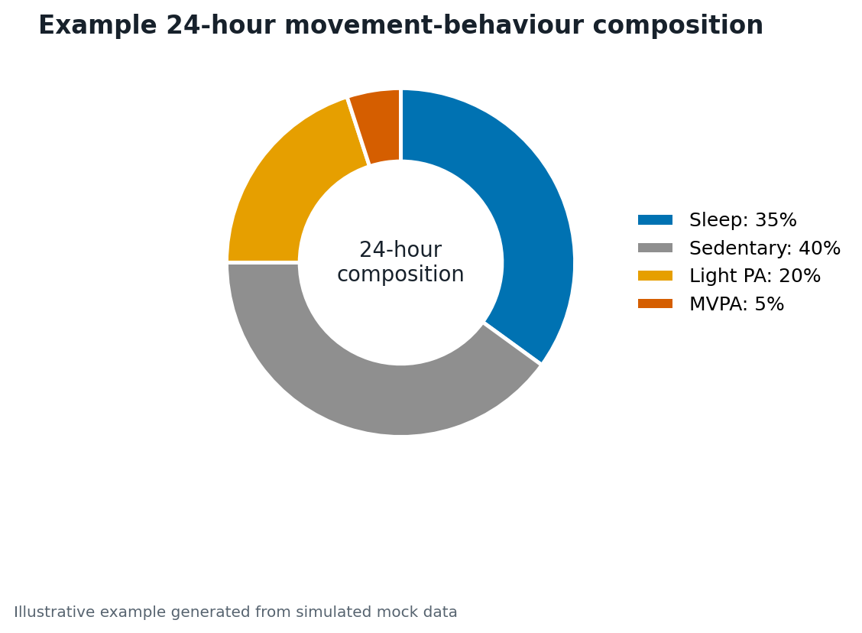
Simulated data example illustrating the visual structure for the recommendation: Pie or doughnut chart.
Source: Simulated mock data.

Simulated example 17. 100% stacked bar chart
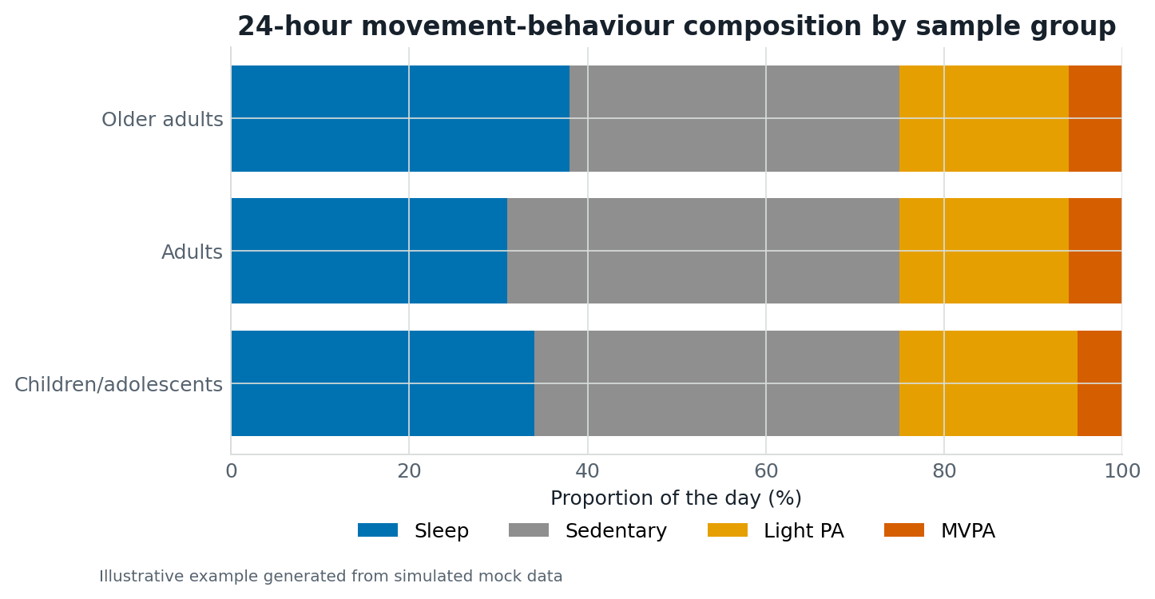
Simulated data example illustrating the visual structure for the recommendation: 100% stacked bar chart.
Source: Simulated mock data.

Simulated example 18. Small-multiple composition bars
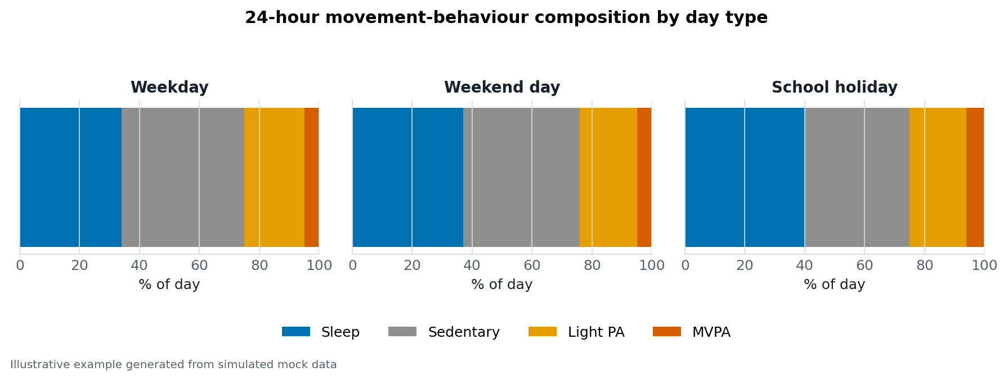
Simulated data example illustrating the visual structure for the recommendation: Small-multiple composition bars.
Source: Simulated mock data.

Simulated example 19. Ternary plot
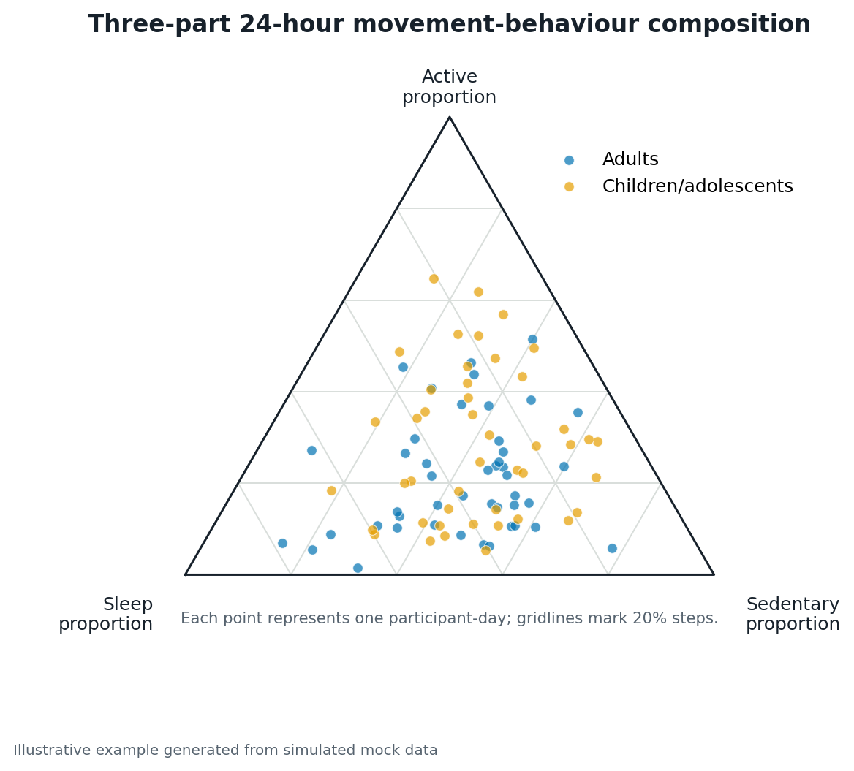
Simulated data example illustrating the visual structure for the recommendation: Ternary plot.
Source: Simulated mock data.

Simulated example 20. Scatter plot
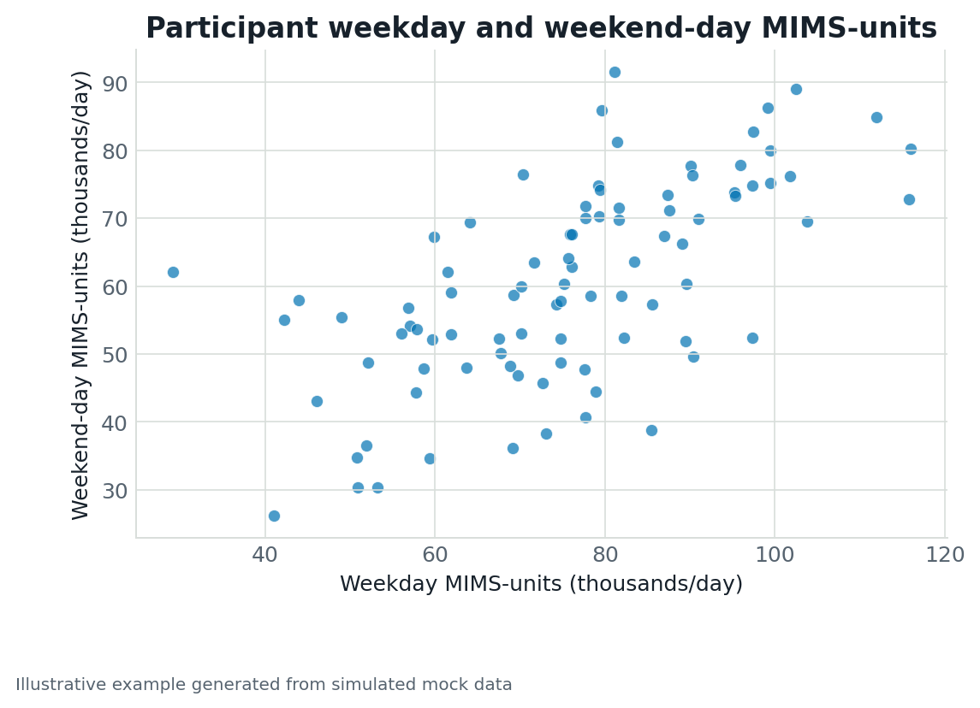
Simulated data example illustrating the visual structure for the recommendation: Scatter plot.
Source: Simulated mock data.

Simulated example 21. Event timeline or raster plot
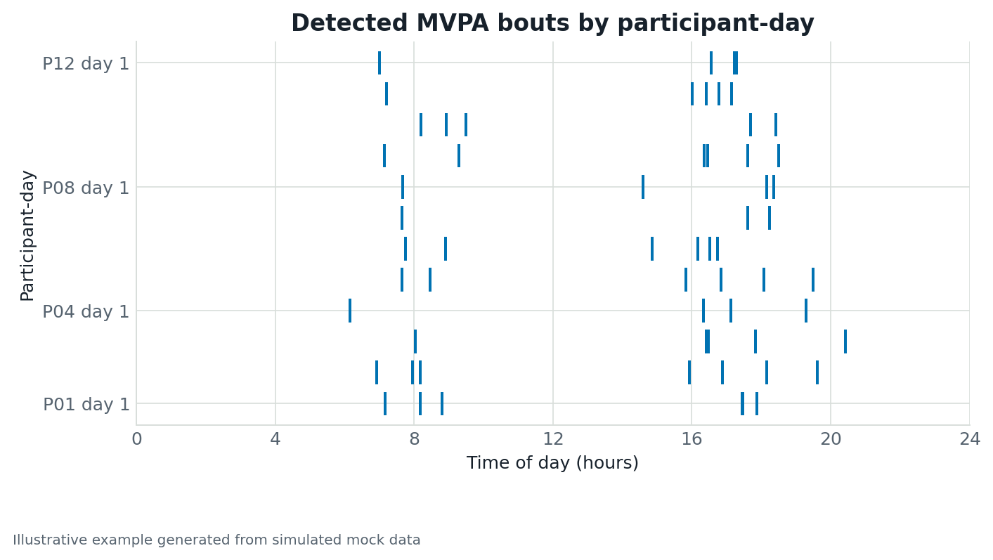
Simulated data example illustrating the visual structure for the recommendation: Event timeline or raster plot.
Source: Simulated mock data.

Simulated example 22. Event raster or time-bin heatmap
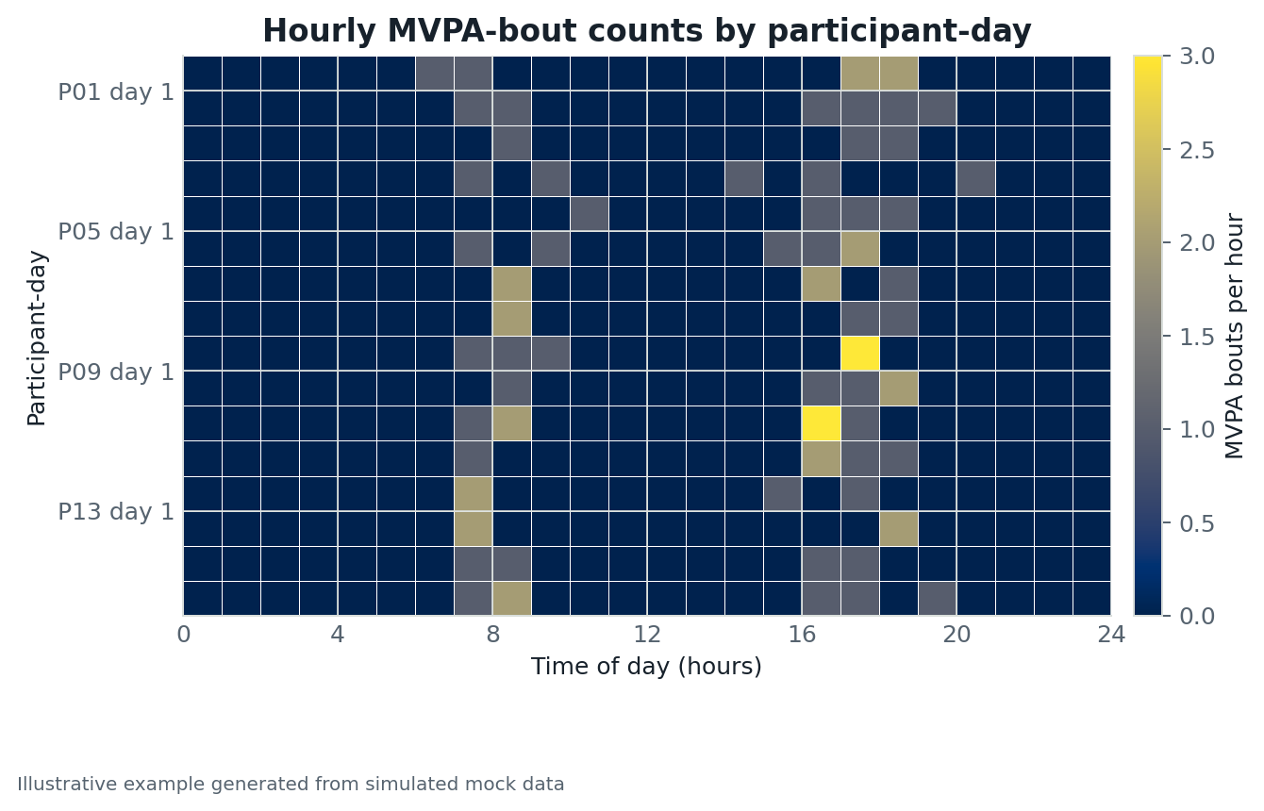
Simulated data example illustrating the visual structure for the recommendation: Event raster or time-bin heatmap.
Source: Simulated mock data.

Simulated example 23. Event-frequency time profile
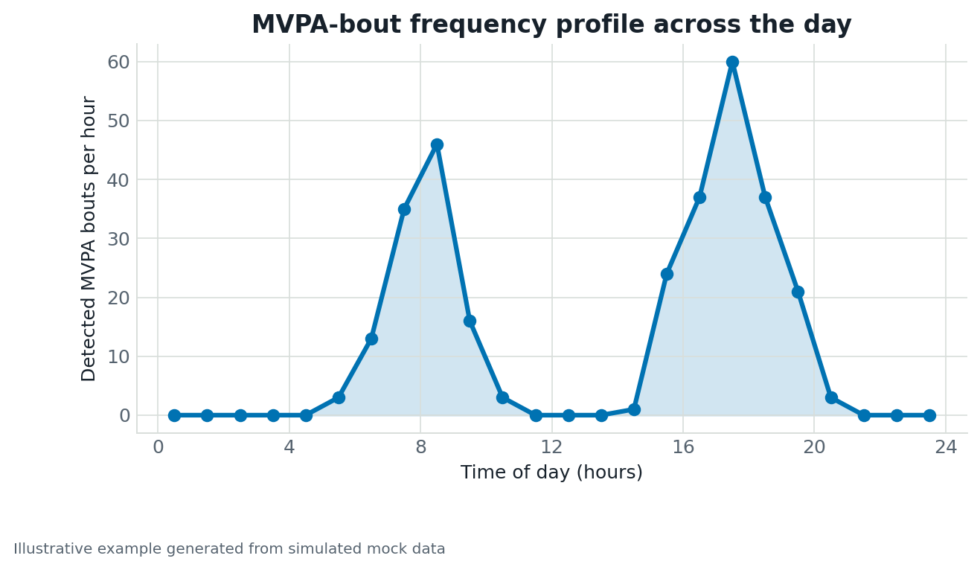
Simulated data example illustrating the visual structure for the recommendation: Event-frequency time profile.
Source: Simulated mock data.

